Introduction
DifferentCoat is an object-oriented Java application designed to automate paint calculations for customers. The system categorizes users as Trade or General Customers, processes their paint requirements, and ensures accurate estimations based on surface area or room shape dimensions.

This documentation provides Guidance On
Installation & setup
Application structure
Testing procedures

Installation & setup
Before using DifferentCoat, please ensure the following are met

Requirement | Details
Java Development Kit | JDK 17 or later
Installed IDE | IntelliJ, Eclipse or Visual Studio Code
Testing Suite | TestNG
Data Import | CSV file for customer data

Please ensure the POM files are updated to include dependencies, as shown below:
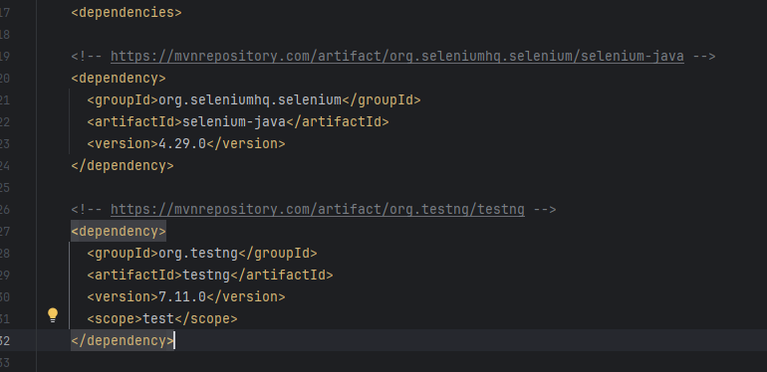

See DifferentCoat Zip file provided. Please right-click on the zip and select extract all. Select your desired location to store the file.

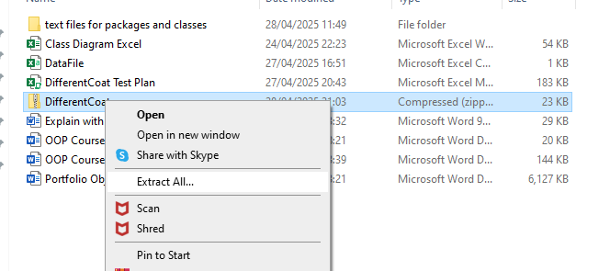
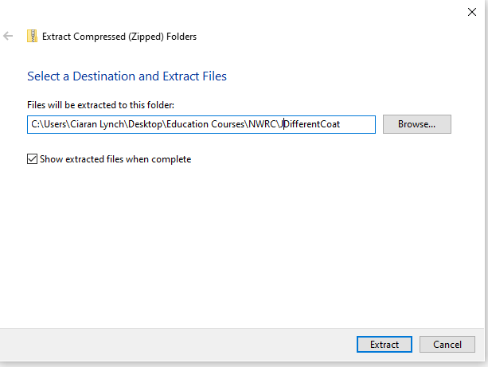
Select – Extract.
Open your preferred IDE and select-Open
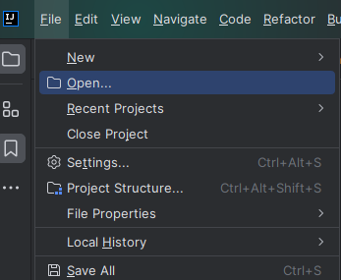

Select the path that you selected. You may get a Trust and Open Project warning, from your IDE. Select Trust Project.
You will get a Maven build script message. Select Load
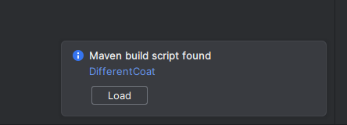
In the folder provided, there is also a DataFile. This is your csv file holding all the necessary customer data. Ensured this is saved in the same location.
Open the Demo Class from the side panel Project window, from the Main Package.
You can run the Demo class from the top menu bar.
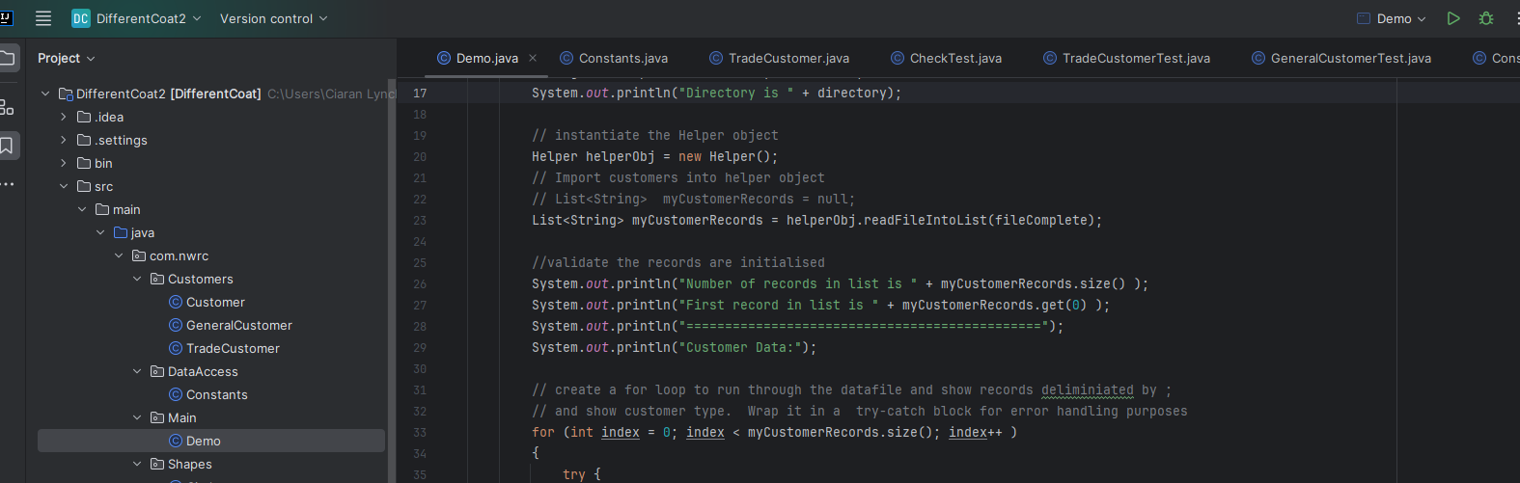
On the bottom Terminal window, you will see the output results.
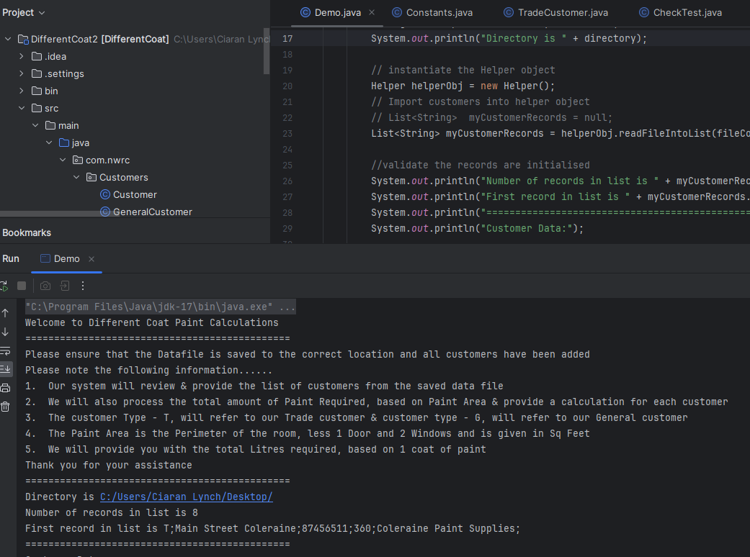
Notice the filepath declared in the Main class for the csv file:
String filePath = "C:\\Users\\Ciaran Lynch\\Desktop\\DataFile.csv";
Please change to your location, as appropriate.
NB notice the double backslash \\ to the file directory path. This is for IntelliJ IDE
Eclipse will use “C:/Users/Ciaran Lynch/Desktop/Datafile.csv”;

Application Structure
DifferentCoat follows a modular package structure for better organisation. Package names include:
Module | Description
Customers | Manages Customer classification
DataAccess | Holds Constant variables required
Main | Controls application execution and paint calculations
Shapes | Defines geometric calculations for room shapes
Utilities | Handles CSV imports in the Helper class
AllTests | Implements unit testing with TestNG

Testing procedures
DifferentCoat uses TestNg for automated unit testing. To run tests in IntelliJ, right click on the testing.xml file in the project panel and select -run
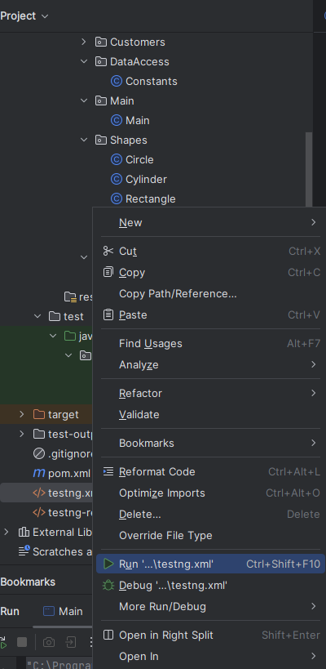
Review results in the lower Terminal window.
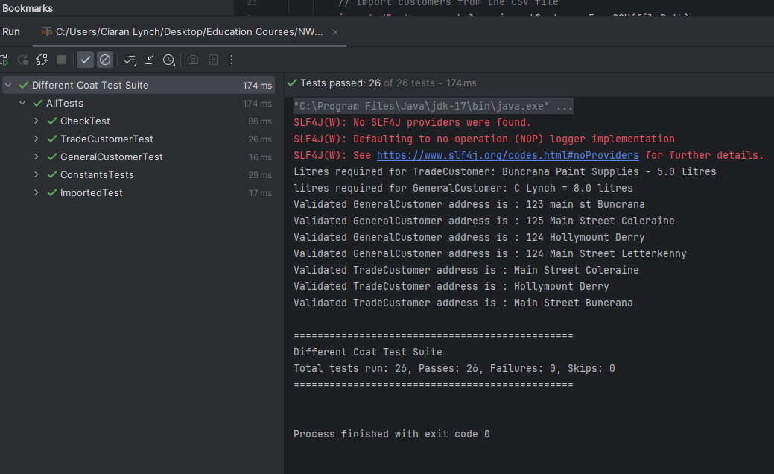
TestNG will also provide a test-Output folder after running the test. Within this folder an emailable-report.html will be created. You can view this by right-clicking, select -open in – Browser and select Chrome.
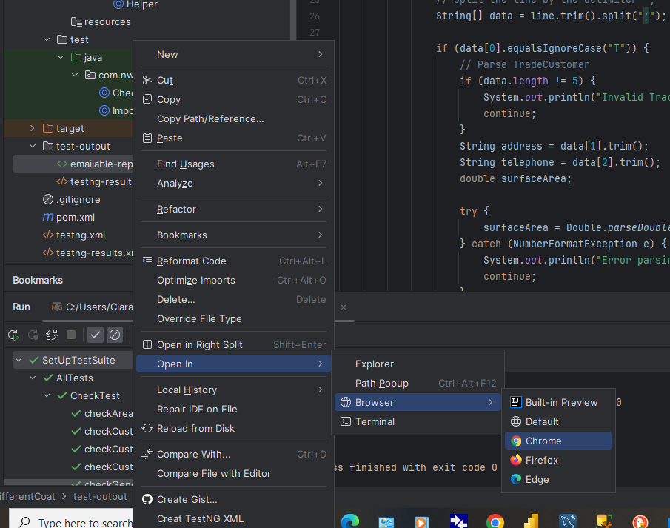
See below example of the emailable report.
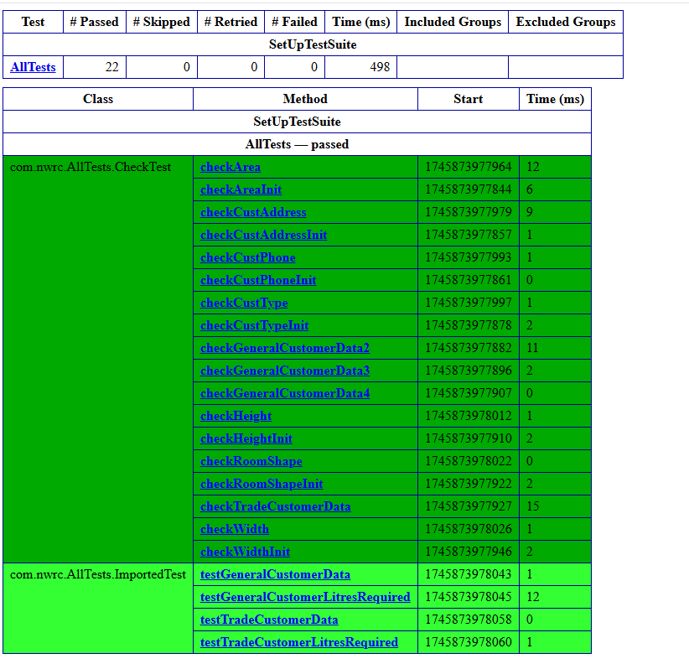
Conclusion
This documentation ensures developers and users can correctly set up, operate, and maintain DifferentCoat. By following troubleshooting and testing procedures, the system remains functional and reliable.

